Call for Entries

With the emphasis on the importance of great planning in our own region, our awards program is now held in October to align with the many national festivities during the American Planning Association's (APA) National Community Planning Month and celebration of Great Places in America!

This awards program is a well-respected tradition honoring
the very best in planning and design in Hillsborough County.

Winning projects contribute to a better quality of life and serve as models to learn from and emulate in planning and design.
Call for Entries
The Planning Commission is currently soliciting
entries for our 32nd Annual Awards Program.

| Dates to Remember |

August 27, 2014 | Submissions Deadline

Complete submission package with entry fees must be
delivered no later than 5:00 p.m. on August 27th to:

The Planning Commission, 18th floor
601 E Kennedy Boulevard, Tampa, Florida 33602

The $160 entry fee must be made payable to:
Board of County Commissioners

The $160 entry fee may be waived for student designed projects or
for projects designed and executed entirely with volunteer resources.

All entries become property of the Planning Commission. Photos and drawings submitted may be used by the Planning Commission in materials including
websites, publications, presentations, and educational programs.
No entry materials will be returned.

October 30, 2014 | Winners Announced

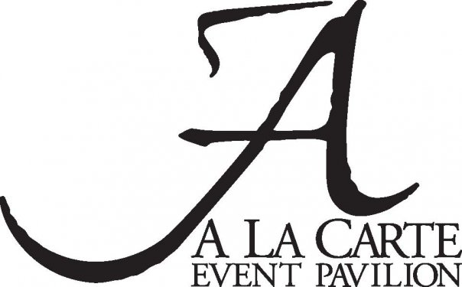
32nd Annual Planning & Design Awards Program
presented by Tampa Electric • Peoples Gas at the
Hosted by
ABC Action News Anchor
Brendan McLaughlin

Cash Bar Reception | 6:15 p.m.
Dinner & Presentations | 7:15 p.m.
Tickets | $50 – will go on sale beginning in September
Categories

- Housing | Live:
| residential | affordable housing | subdivisions |
| townhomes | apartments | condos |

- Commercial | Work:
| employment & commercial from small business to large industrial |

- Entertainment | Play:
| parks | recreation areas | arts | culture | museums |
|entertainment | sports and community centers |

- Investment | Thrive:
| educational | financial | medical | religious | civic |
| governmental | infrastructure | transportation |
| economic development | public-private partnerships |

- Redevelopment | Redevelop:
| urban infill | adaptive reuse | brownfields | mixed use development |

- Historic | Preserve:
| preservation | restoration |

- Environmental | Sustain:
| conservation | sustainability | natural resources | going green |

- Planning | Plan:
| master plan or studies | urban design | overlay districts |

- Participation | Engage:
| public engagement | public education | community service |

Students in Planning

Entries may include student designed projects from any award category. Judging guidelines for each respective category will be considered. Students and faculty involved in winning projects will receive an award certificate.
Eligibility

The Planning Commission’s Community Design Awards program is open to all planners, residents, developers, builders, architects, community groups, design professionals, local governments, students or other interested parties. To be eligible for consideration this year, proposed entries must be located in Hillsborough County and have been completed within the last five years (on or after 01/01/2009). No entries can be accepted that have or had a direct professional, financial, ownership, design, consulting and/ or construction interest of any current member of the Planning Commission.

Judging

All entries will be evaluated by an independent jury composed of professionals prominent in the fields of planning, urban design, development, architecture, or landscape architecture. All jury members live and work outside of Hillsborough County and are not affiliated in any way with the Planning Commission. Describe your project for the judges in terms that apply to the Criteria. You may enter in as many Categories applicable. The jury will select all winners and may change the category for which a project may receive an award. The judges have sole discretion as to how many projects will be recognized in any category (or none at all).

Designations

• Outstanding Contribution to the Community | projects that exhibit excellence in every aspect of planning, design, and execution

• Award of Excellence | projects that exhibit excellence in nearly every
aspect of planning, design, and execution

• Award of Merit | projects that exhibit excellence in many aspects of
planning, design, and execution

• Jan Abell Award | in rare cases, the jury may select a project that
makes an outstanding contribution above other submissions in the historic preservation category to receive this award

Criteria

The Jury will consider each submission based on the following criteria:

Quality of Life Benefit | Does this project make the community a better place? Examples:
- Promotes historical or environmental preservation, conservation or restoration
- Improves safety and facilities for bicycles and pedestrians
- Supports mixed use development and encourages transit options
- Integrates with and enhances the surrounding neighborhood
- Fosters a sense of place

Originality & Innovation | Does the project have a visionary approach or innovative concept to address needs or challenges in the community?
Examples:
- Uses space effectively and creatively
- Employs a cutting-edge slant in fields like green building or sustainability
- Uses a fresh approach to financing or cost-efficiency

Quality & Comprehensiveness | Does the entry represent excellence from the planning process through implementation? Examples:
- Excellence in analysis, writing, graphics, design, and implementation
- Has a positive impact on public objectives in the surrounding region
- Has addressed community needs with long range vision

Implementation & Transferability | Does the entry serve as a model for others to learn from? Examples:
- Paves the way for future projects by clearly demonstrating what to do to get it done
- Fosters good planning through its methodology or components

Education & Engagement | Does the entry clearly demonstrate meaningful public involvement? Examples:
- Employs a variety of user-friendly tools to include the entire community, including those traditionally underserved
- Provides meaningful opportunities are is responsive to the public’s involvement
- Increases awareness in the community of the benefits and importance of good planning
Submissions

Entries will be accepted only in digital format (CD/DVD/thumbdrive) with all items on the checklist below no later than August 27, 2014 at 5 p.m.
What’s the project all about?
- Project Name and Entry Category (Projects can enter in multiple categories, but judges may adjust the category if they choose. Winners will receive only one award.)
- Contact Information - Name, Phone, and Email (in case we have questions)
- Map with Project Location
- Links to the project web site(s) or related social media (if applicable)
- A 150-word maximum Summary Description of the project
- A maximum of three-pages describing of how the project meets criteria and makes Hillsborough County a better place among within its category
- Seven - ten quality Photos, Drawings, and / or Schematics (jpg format)
- Site Plan and / or Aerial photo (if applicable)
Who should be recognized for this project?

- Name, affiliation, phone number and email address for ALL individuals associated with this project who should receive invitations to the October 30th Dinner and Awards Program at A La Carte Pavilion
- Names of up to three organizations or individuals for awards statue
- Name, affiliation and role played of up to six project team members to be recognized during the awards presentation

Please note: There will be no site visits by the jury, so it’s up to YOU to clearly present your entry to the judges in words and pictures. If you have questions,
please contact us at pada@plancom.org or by calling 813.272.5940.

Deliver your complete submission package with the $160 entry fee made payable to the Board of County Commissioners no later than Wednesday, August 27, 2014, at 5:00 p.m. to pada@plancom.org or:

The Planning Commission
601 E Kennedy Boulevard, 18th Floor
Tampa, Florida 33602

