KEYSTONE-ODESSA COMMUNITY PLANNING AREA
Location
The Keystone-Odessa Community Plan Area delineates the boundary established during the community planning process and within which the Vision and strategies discussed herein are to be considered. The Keystone-Odessa community plan study area is located in northwest Hillsborough County and is generally bordered on the west by Pinellas County, on the north by Pasco County, on the east by Dale Mabry Highway, and on the south by the Urban Service Area boundary.
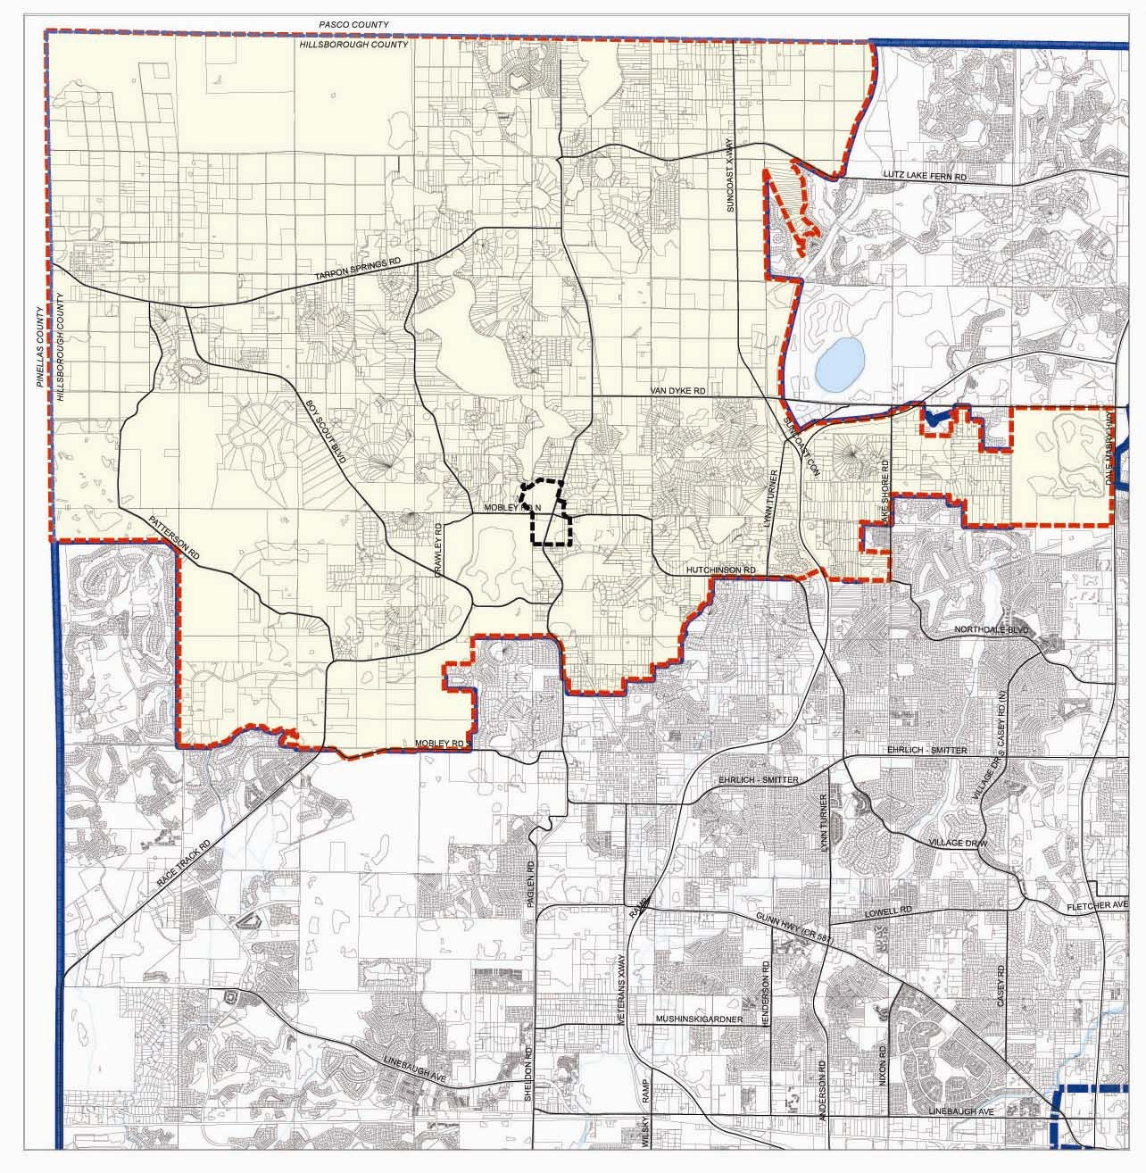
Figure 4 – Keystone Odessa Community Plan Boundary Map
Vision

The Keystone-Odessa community will continue to be a rural community, embracing its agricultural past. Its continuing desire is to be an open area that: values nature above commercialism; dark, star-filled skies at night above the glare of urban lights; and, the sound of crickets and frogs above traffic noise.

Blessed with many lakes, wetlands and creeks; and dependent on water wells for survival, these will be supported to ensure their continued health. Protection of water resources will be paramount.

Rural roads that transect the Keystone-Odessa community will remain in their present form (two-lane local and collector roadway connections for movement without entering major arterial highways), freely used by community residents. Urban design standards and/or traffic generated by surrounding high population centers are not to degrade the community’s country roads.

Strategies
To ensure the implementation of the Vision formulated by the residents of the Keystone-Odessa community the following strategies have been adopted in the County’s Land Development Code to guide future growth and redevelopment. The illustrated plan in Figure 2 (of the Keystone-Odessa background documentation) locates gateways, the rural activity center, open spaces, and greenway connections.

Rural Residential Community Character
The Keystone-Odessa community desires to retain its rural residential character as an area of lakes, agricultural activities, and homes built on varied lot sizes and in a scattered development pattern. Rural is based on the County’s Future Land Use Element, Urban Service Area boundary objectives and policies.

Rural design guidelines were developed to implement the Keystone-Odessa Community Plan in order to retain the rural residential character of the Keystone-Odessa community planning area. These guidelines have been incorporated into the County’s land development code. The adopted provisions do not apply to previously approved planned developments, previously approved subdivision, or any project with unexpired preliminary site development approval prior to the August 1, 2002 adoption date. The community recognizes the development pattern of those projects, but not to continue a similar development pattern other than the adopted Keystone-Odessa Rural Development Standards in the County’s Land Development Codes which include standards that:

- achieve "compatibility" between new and existing uses;
- protect the area from suburban and urban sprawl;
- maintain ecological balance;
- improve design aesthetics to make the physical development of the community more attractive;
- protect natural resources through clustering development, when appropriate;
- define the area’s unique architectural design;
- preserve natural areas in residential lot development;
- improve local vehicular circulation between uses;
- provide for ground level monument signage standards;
- include screening and buffering requirements;
- provide for nighttime lighting standards (minimizing light pollution);
- provide for the development of paths and trails where appropriate to move people without cars; and,
- recognize the pre-existing urban scale subdivisions and commercial developments do not set a precedent for additional development of this density and design.

General Development Criteria
To maintain the scenic visual quality of open and agricultural lands in the Keystone-Odessa community, development criteria that embraces the area’s agricultural past is defined under the following headings.

Fences and Barriers
Minimal use of walls or opaque screening materials which act as fences or barriers will be used in the community. Commercial and residential property owners using screening materials other than vegetation are required to use rural fencing materials; e.g., split rail, 3 or 4-board, barbed wire, horse wire and hog wire. Opaque screening materials along public right-of-ways, other than vegetation will not be permitted.

Residential
The established rural pattern of residential development will be continued and the intrusion of suburban style residential development will be prohibited as defined by the Keystone-Odessa Rural Development Standards adopted in the County’s Land Development Code which provides for:

- maintaining low-density residential development of a minimum of one unit per 5 acres consistent with the comprehensive plan (unless otherwise permitted);
- discouraging plan amendments to densities higher than 1 du/5ga;
- addresses situations where densities have been permitted greater than 1 du/5ga, (in those cases regulations):
- allow for the transfer of those development rights to area inside the Urban Service Area (USA);
- permit development to cluster on larger acreages to achieve meaningful open space and agricultural lands;
- on lots smaller than 2 acres, develop building square footage to lot ratios or other tools to create compatible development between older, smaller lot development and new development;
- require minimum open space and varied setbacks for rural residential lots; and,
- eliminate the ‘flex’ provision within and into the community boundaries.

Agriculture
The Keystone-Odessa community desires to support the existing agricultural uses and ensure that development standards accommodate new agricultural uses. It seeks to do so through development regulations and mechanisms that support and expand existing and new agricultural uses including citrus, farming, ranching, and equestrian facilities. In order to achieve this outcome the following are recommended:

- regulations which permit individuals to build and maintain accessory structures for farm animals on agricultural-residential property to reflect the nature of the area as agricultural rather than suburban;
- the use of the greenbelt property tax exemption being monitored to ensure that it is appropriately used on bona fide agricultural properties;
- encourage preservation of open space as an asset to the community and provide tax relief to maintain open space to keep it that way;
- allow for the creation of uses which compliment the community character such as riding stables, horse track support facilities, and equestrian facilities; and
- allow private barns on small agricultural properties, and other regulations (such that solid waste requirements are flexible enough to accommodate small land holders).

Commercial
Keystone-Odessa Rural Activity Center
The Keystone-Odessa community desires to have uses that are geared to serving the daily needs of area residents, in a scale and design that complements the character of the community. It is the desire of the community to encourage transfer of development rights for some of the currently approved unbuilt commercial within the community planning area and to direct new commercial to the intersection of Gunn Highway and North Mobley Road with the community plan boundary, and to other eligible receiving areas in Hillsborough County.

The intersection at Gunn Highway and North Mobley Road is recognized as a rural activity center by the community, and designed to serve the majority of the community’s daily shopping needs such as groceries, post office, animal supplies, etc. To ensure that the area is developed in compliance with the Keystone-Odessa Community Plan this area has been defined as an overlay district within the County’s land development code. The overlay district incorporates specific design guidelines that include:

- staggered building orientations, with interruptions in roof lines and structures;
- public courtyards or open space(s) with shade trees;
- architectural features to emphasize the location of the center;
- connected structures with covered walkways made of pavers, brick or boardwalks;
- residential style pitched roof lines;
- external facades made of wood siding, brick or vinyl material;
- preserved natural areas to act as buffers along perimeters;
- irregular vehicular circulation and parking patterns to accommodate existing trees;
- signage in scale and related to architectural character of the center (externally illuminated monument signs not pole signs);
- drought tolerant tree and vegetation plantings for shade, screening and buffers along roadways; and,
- nighttime lighting that mimics gaslights or kerosene lights.

The Gunn Highway and North Mobley Road rural activity center area (overlay district) is generally shown on the illustrated plan (of the Keystone-Odessa background documentation).

Other Commercial
The desired rural commercial character for the Keystone-Odessa community includes uses which:

- are small in scale; (both in square footage for individual structures and in the FAR);
- are specifically geared to serve the agricultural and equestrian interests in the area;
- are designed using an architectural style which reflects a rural vernacular with metal or wood shake roofs; and,
- have exterior walls constructed of natural materials (vs. a “franchise architecture” appearance).

Tourist/Leisure Industries
The Keystone-Odessa community recognizes that its attractive natural amenities, and active equestrian accommodations and related activities are unique characteristics that attract tourists. Regulations adopted in the County’s land development code will ensure the continuation and expansion of uses that support the equestrian and agricultural activities for their tourist value. These land development regulations will support the creation of uses such as bed and breakfasts, dude ranches, riding stables, horse track support facilities, and equestrian facilities (in scale and designed to be compatible with the community).

Schools
The educational needs of the children in the Keystone-Odessa community are a high priority for the residents of the community. As the School District of Hillsborough County determines that additional school facilities are needed to serve these children, the citizens of Keystone-Odessa respectively request that:

- the planning and development of schools reflects the rural character of the community and to serve the student population of Keystone-Odessa;
- a public involvement program is utilized which includes meaningful input from the community in the development of a long-range plan, for school location within the community; and
- schools and other publicly owned community facilities such as libraries, parks and community centers can be co-located to allow for shared resources and savings in cost.

Streetscape/Roadway
Residents of Keystone-Odessa want an integrated shaded streetscape/roadway system, which visually enhances its corridors. To do so:

- canopy trees along roadways designated as scenic corridors will be protected;
- planting programs of drought tolerant trees and vegetation along roadways identified as scenic corridors and/or greenway trails will be undertaken to create a sense of place, and to improve or preserve specific views;
- Gateways, located to create a sense of arrival through a change in character from the surrounding landscape are identified. These gateways, developed through local community input are intended to create a lasting impression through:
- the selection of signage;
- location of structures;
- proximity of drought tolerant shrubbery or other vegetation; and
- roadway layout/configuration;
- residents will work with utility providers to determine ways to minimize the use of overhead utilities; and,
- street lighting should not be required nor permitted unless public safety is at risk.

Transportation
The Keystone-Odessa community is presently served by a system of two-lane roadways. Gunn Highway is a primary north/south roadway with Boy Scout, Patterson and Race Track Road all serving in that similar capacity. Van Dyke, Lutz-Lake Fern, Tarpon Springs, North and South Mobley roads all provide east to west travel. Several other significant roadways serve the community: Hutchinson, Tobacco, Lakeshore, Lake LeClare Roads are just a few. In recent years, the Veterans Expressway has been constructed through the community providing limited access at Van Dyke, and Hutchison Roads. The Suncoast Expressway is the northern extension of the Veterans Expressway. Within the Keystone-Odessa area an improved intersection has been constructed at Lutz-Lake Fern Road.

These limited access facilities should be seen as relief for the heavily traveled roadways in the Keystone-Odessa community, particularly for Gunn Highway, which serves Pasco County travelers, as well as Hillsborough County.

The Keystone-Odessa community borders both Pasco County and Pinellas County, both of which are experiencing suburban growth close to the Keystone-Odessa area. The Suncoast Parkway, the improved Dale Mabry, and U.S. 41 Highways all provide substantial north/south access between Hillsborough and Pasco Counties. East-west traffic from Pinellas has limited choices, however the connection of State Road 584 and Forest Lakes Boulevard, and Linebaugh Avenue into northern Pinellas provides an additional choice for travelers headed into Hillsborough County. The community supports the expansion of the Suncoast Parkway to 6 lanes (3 lanes in each direction) to relieve traffic through the Keystone-Odessa Community Plan area.

Residents want to retain the existing roadways as two-lane facilities geared to primarily serve local traffic. While it is understood that over time some changes to roadway configuration may be needed for safety, the residents want to limit those changes to turn lanes, pedestrian/equestrian crossings or traffic control mechanisms rather than widening the roadways.

Gunn Highway will be identified as a County roadway, which cannot be widened further due to social, economic, policy and environmental constraints. The identified and designated constrained corridors list found in the Transportation Element will also be recognized. The truck route on Gunn Highway from the Pasco County Line to Van Dyke is enforced as set out by the adopted Hillsborough County Truck Route Ordinance.

Equestrian trail connections are important and should be considered in-line with future improvements. Measures such as traffic calming, inter-modal connections to disperse impacts, and diverting traffic to the Suncoast Expressway are also to be considered.

Livability/Safety
In order to ensure livable roadways in the community the County shall encourage development of pedestrian and equestrian trails along roadways identified in the 2015 Scenic Corridor Map as amended, in the Future Land Use Element. Off-road pedestrian/equestrian trails and bikeways will be developed whenever possible in the preserved greenway corridors identified in Hillsborough Greenways Master Plan. Off-road trails and bikeways will be developed when possible in these greenways. The 1995 Greenways Master Plan was used in identifying pedestrian trails, which should be included to provide connectivity.

Water Quality and Quantity Goals (Wetlands, Open Space, Environment, Wildlife, and Natural Systems)
Improving existing protection and understanding of water resources found in the Keystone-Odessa area like wellfield and lake/creek protection, is recognized as a high priority needed to ensure healthy ground and surface water resources for humans and the environment. Specifically, the Rocky and Brushy Creeks and the Brooker Creek riverine system are to be protected and preserved.

The community seeks to create continuity and connectivity to surrounding communities through designation of a system of greenways and open space preserves. To do so it will continue to designate areas including acquired ELAPP areas, parks, wetlands and greenways/trails to be part of a system of open space preserves to remain protected from development in perpetuity. The County is asked to consider the transfer of development rights for potential reserve areas currently designated as significant wildlife habitat area, lands approved for purchased ELAPP, and wellhead protection buffer areas, to be adopted as part of the land development code. To promote continuity and connectivity and to protect and preserve natural areas the community recognizes the following approaches:

- density calculations for clustered developments in the community will be based on upland areas;
- no density credits will be assigned to wetland areas for new development;
- stormwater management plans that contribute to the open space system of preserve areas and protect the historic drainage patterns of the community’s drainage basins should be developed; and
- regulations or other mechanisms that provide land designated as open space be maintained in perpetuity should be explored and placed into the land development code, where appropriate.

Improving existing protection of water resources is a high priority. To ensure healthy lakes and wetlands for aesthetics and recreation by preserving the aquifer and moving water in a natural way:

- Excessive withdrawals of groundwater for new development that reduces both the resource and its potable qualities will be avoided to ensure safe and adequate ground and surface resources for all users and the environment;
- Current natural drainage systems, like wetland sloughs and bayheads, will be improved and/or maintained by removing exotics and reducing public supply wellfield pumping;

- Habitat areas for viable wildlife populations will be protected through public acquisition of land and voluntary dedications and through other incentive programs;
- The County will study, and amend as necessary, current comprehensive plan policies and the land development code, to ensure the protection and sustainability of lake resources for the long term;
- New lakefront development shall be required to retain a natural vegetative buffer, for the water quality and wildlife benefits it affords. New hardened shoreline is prohibited, and existing hardened shoreline shall not preclude the requirement for the preservation of a vegetative buffer. However, these requirements should recognize the provision for recreational access which minimizes impacts to these natural resources;
- In recognition of the perception among residents, that the variance process for lakefront environmental protection regulations is failing to adequately protect lake associated natural resources, the County shall review and amend this process, as necessary;
- Densities and intensities on lake front property should be restricted in order to protect water quality. This would recognize the need for regulations, specific to water front property, which will protect the natural resource in the long term;
- In recognition of the importance of lake associated wetlands to the ongoing health and sustainability of the lake resource, lake associated wetlands should have protection in excess of isolated wetlands;
- The County should strengthen its efforts to educate lakefront property owners. This is considered the most effective method of protecting lake water quality on developed lake shorelines. A significant amount of natural resource degradation is the result of uninformed property owners; and
- The County should expand its lake watershed study program in an effort to systematically address the problem of natural resource degradation in Hillsborough County.

